

Thank you for doing the ‘meet and greet’ role for our home.

You may be asked to show visitors around the home, including:

* people who are attending a job interview
* family members
* new service users and their family
* new colleagues.

Where possible, the Activities Team will let you know when someone wants to visit the home so you can prepare.

When you get a visitor to the home, here are the steps that you should follow.

|  |  |
| --- | --- |
|  | |
|  | Go to reception to meet the visitor - say hello and tell them your name. |
|  | Welcome the visitor to your home and have a short chat. |
|  | Introduce the visitor to the Home Manager. |

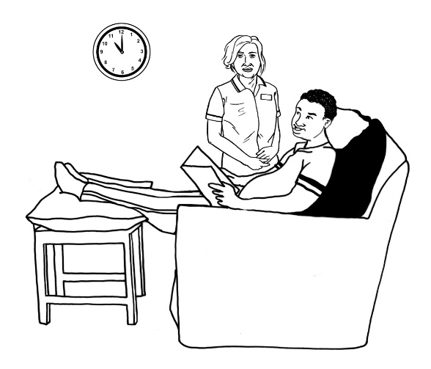

|  |  |
| --- | --- |
|  | Tell the visitor that you will come back to show them around when they have spoken to the Manager. |
|  | Go back to your unit and wait until the visitor is ready to have a look around. |
|  | After the visitor has spoken to the Home Manager, the Activities Team will come and get you. |
|  | Go back to the reception and show the visitor around the home – introduce them to people you see and answer any questions. |
|  | Show the visitor your bedroom, if you feel comfortable to. |
|  | Show the visitor the garden and share the activities that happen in the garden. |

|  |  |
| --- | --- |
|  | Show the visitor the quiet room and lounge, and share the activities that happen in these rooms. |
|  | Show the visitor the dining room and tell them about the food at the home. |
|  | Share anything else that you think is interesting about the home. |
|  | When you have finished showing the visitor the home, take them back to reception.  Thank them for visiting your home and take them to a member of staff. |

