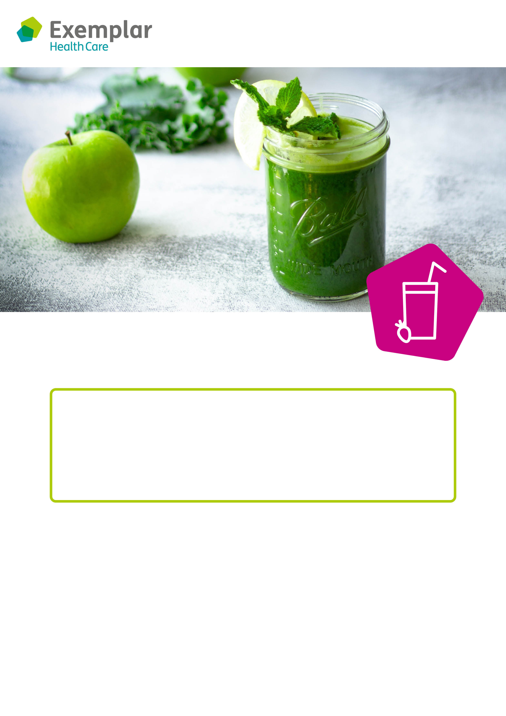

**Day:**

**Time:**

**Where:**

**rts and crafts**

**Smoothie making**

**Come and join our smoothie making sessions!**

Smoothies are delicious, healthy and great fun to make!

At our smoothing making sessions, you can choose what goes in your smoothie – we’ll provide a range of fruits, milks, juices and yoghurts for you to choose from.

We look forward to seeing you.