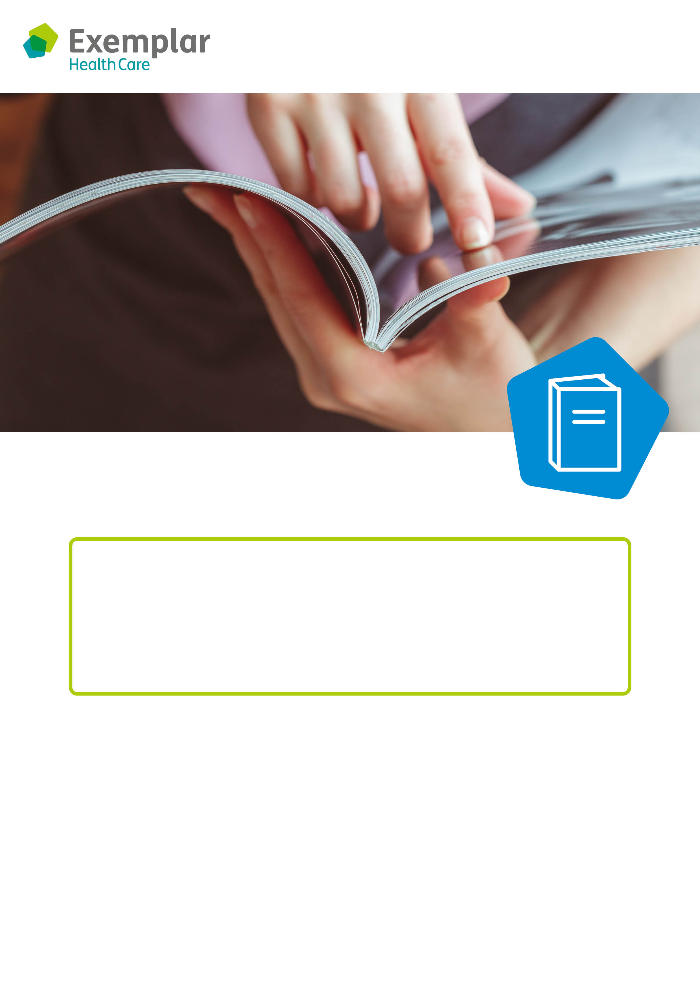

**Come and join our reading group!**

If you love reading, or being read to, we would love to see you at our reading group.

Reading is a great way to keep your brain active, reduce stress and improve your communication skills. We have a variety of reading materials for you to choose from including short stories, audio books, novels, poems, magazines and newspapers.

You can chat with friends about your favourite stories, or just relax and enjoy flicking through a magazine.

We look forward to seeing you.

**Reading group**

**Day:**

**Time:**

**Where:**

**rts and crafts**

to seeing you.