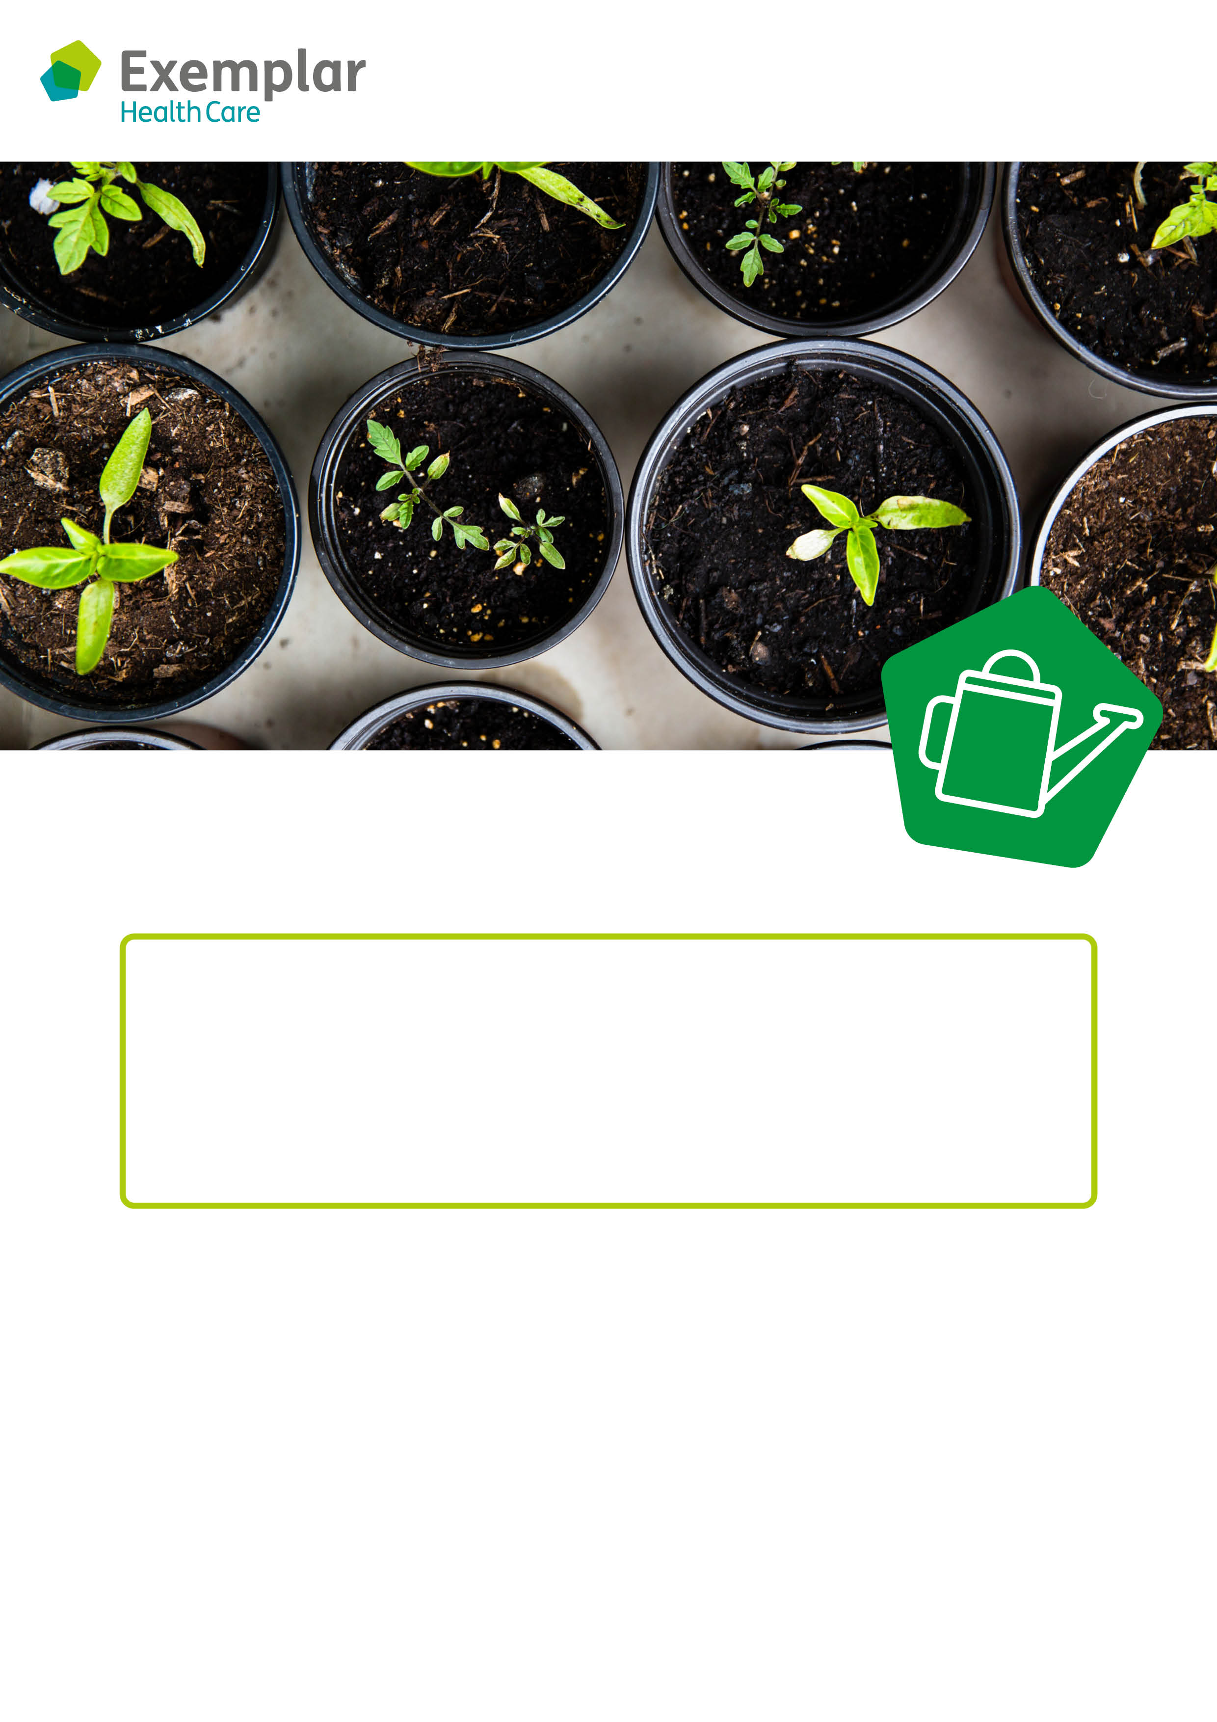

**Come and join our weekly exercise class!**

Gardening has lots of health benefits – it’s a great way to keep active, enjoy fresh air and socialise with other keen gardeners.

It’s very rewarding to watch a seed grow into a beautiful flower, that you can enjoy looking at on a sunny afternoon.

Come and join the gardening group and help us to keep our outside space looking neat and tidy. We have all of the equipment and will support you to learn new skills.

We look forward to seeing you.

**Gardening club**

**Day:**

**Time:**

**Where:**

**rts and crafts**