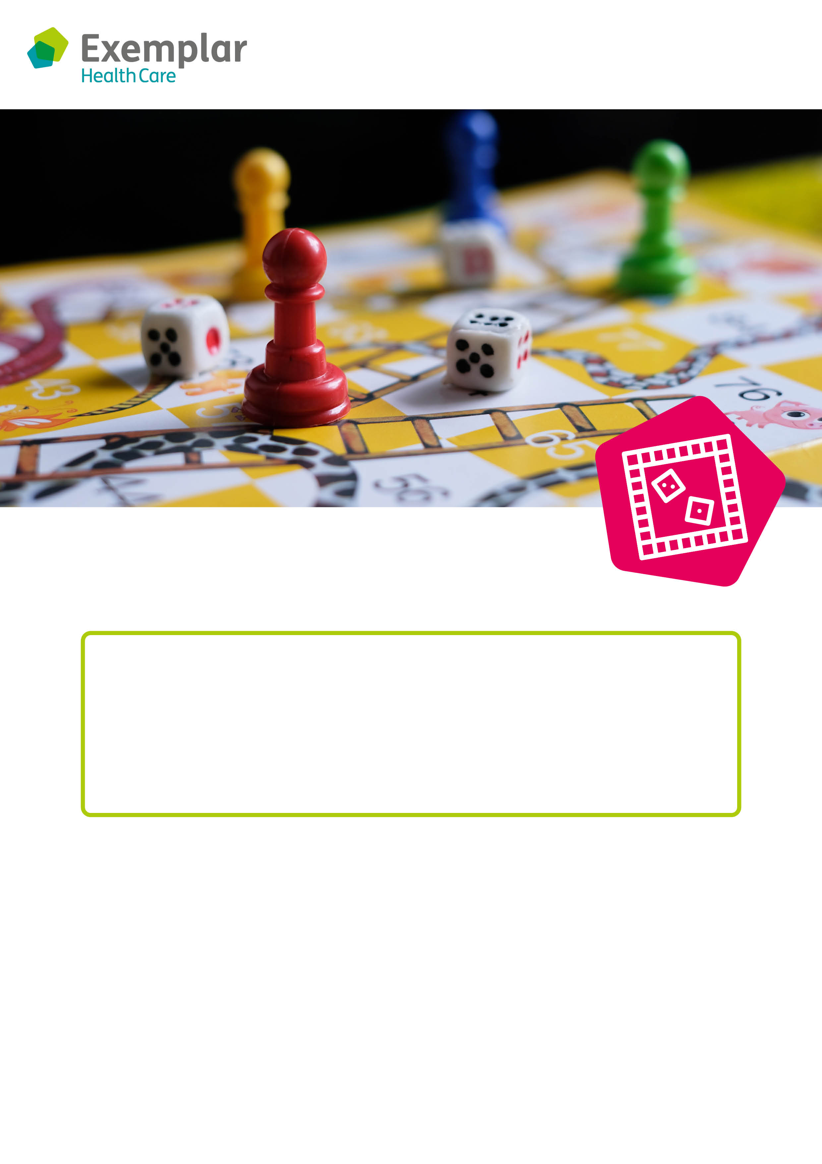.

**Board games**

**Day:**

**Time:**

**Where:**

**rts and crafts**

**Come and join our board games café!**

Board games are a great way for friends to get together and have some fun.

We have lots of board games available, so let us know your favourite one – and if we don’t have it, we’ll get it!